

Asset Practice Questions: Science

**1. Which of these parts helps the plant to take in water?**

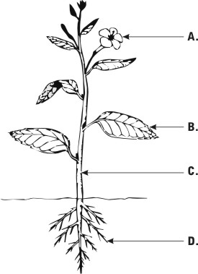

**2. Where are you most likely to find the symbol shown below?**



**A.** On a television

**B.** On a pencil box

**C. On a medicine box**

**D.** On a chocolate box

**3. When we touch a hot pan with our hands we sense it is hot and drop it. Which of these organs helps us sense that the pan is hot?**

**A.** skin **B.** Eyes **C.** Ears **D.** Nose

**4. Prabhu is a poor man living in a village that has no supply of clean drinking water. The only source of water in his village is a small pond of water which has dirt and germs in it. What should he do to make the water safe for drinking?**

**A.** Just filter the water using a cloth.

**B.** Boil the water completely and filter it.

**C.** Add common salt to the water.

**D.** Soak some neem leaves in the water.

**5. Which of these will help us keep our surroundings clean?**

**A.** Walking on footpaths

**B.** Watering the plants daily

**C.** Throwing waste in dustbins

**D.** Removing the petals of a flower

**6. Which of these is got from animals?**

**A.** Coffee **B.** Rubber **C.** Cotton **D. Wool**

**7. Rohini saw an animal that had two legs and feathers. Which animal did she see?**

**A.** Spider

**B.** Caterpillar

**C.** Pigeon

**D.** Horse

**8. Which of these can be eaten raw?**

**A.** Potatoes

**B.** Brinjal

**C.** Tomatoes

**D.** Beans

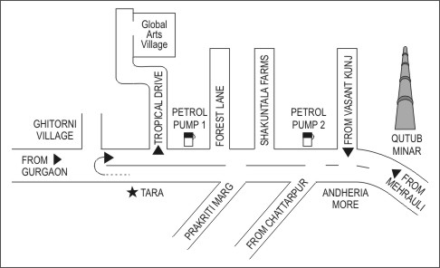**9.**

**Ayesha is travelling from TARA to Qutub Minar. Which of these will she find to her right?**

**A.** Global Arts Village

**B.** Ghitorni village

**C.** Andheria More

**D.** Qutub Minar

**10. In the figure, which of these would fit in place of the question mark?**

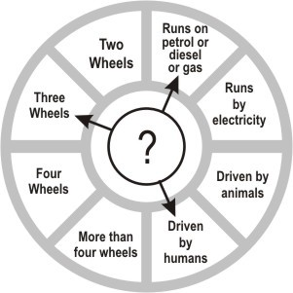

**A.** Auto rickshaw **B.** Cycle rickshaw **C.** Car

**D.** Truck

**11. Arjun: *Does the plant live for more than a year?***

**Ram: *Yes, it does.***

**Arjun: *Does the plant give us shade?***

**Ram: *Yes, it does.***

**Arjun: *Can we see its roots?***

**Ram: *No, we cannot.***

**Arjun: *Does the plant give us sweet fruits?***

**Ram: *Yes, it does.***

**Which plant is Ram describing?**

**A.** Rose

**B.** Coriander

**C.** Mango

**D.** Banyan

**12. From which of these places will we be able to clearly see the largest number of stars in the night sky?**

**A.** A well-lit main road of a city.

B. A dark field away from the city.

C. A cricket stadium when a match is going on.

**D.** The terrace of a building which has many lamps.